1、System topology

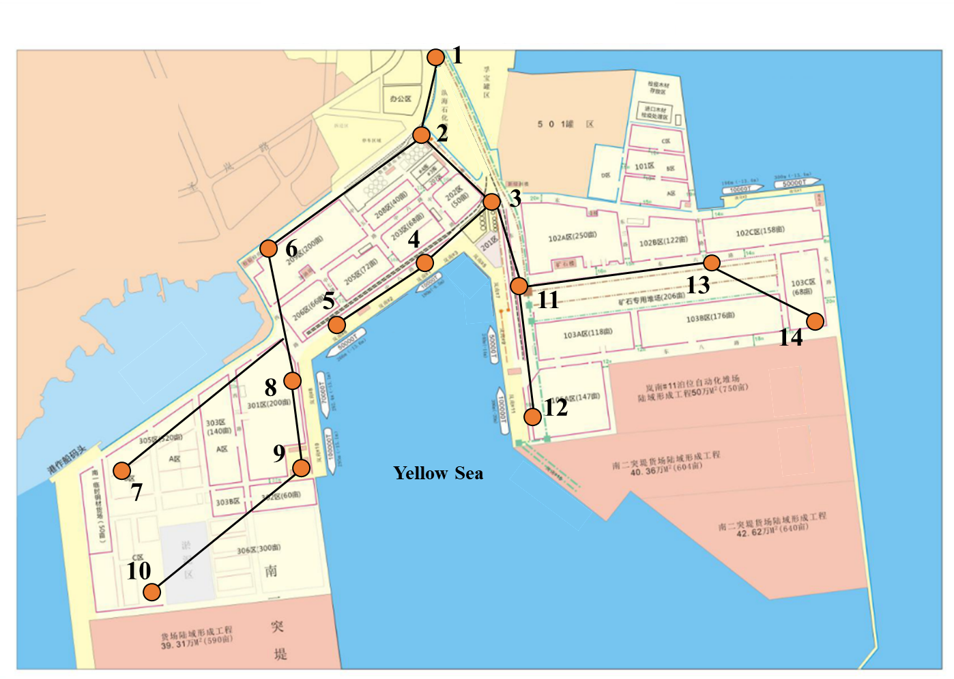

Connection between electrical node and equipment

|  |  |  |  |  |
| --- | --- | --- | --- | --- |
| Electrical Node | Berths | QCs | BSS | Wind Turbine (WT) Units |
| 2 | — | — | 1 |  |
| 3 | — | — | — | WT1 (5MW) |
| 4 | 4 | 7,8 | — | — |
| 5 | 3 | 5,6 |  | — |
| 6 | — | — | — | WT2 (5MW) |
| 8 | 2 | 3,4 | — | — |
| 9 | 1 | 1,2 | — | — |
| 11 | 5 | 9,10 | — | WT3 (5MW) |
| 12 | 6 | 11,12 | — | — |

2、System data

|  |  |
| --- | --- |
| Property | Value |
| Number of available berths | 6 |
| Number of AESs | 8 |
| Number of available QCs | 12 |
| Number of batteries | 30 |
| Number of AGVs | 20 |
| Number of WT units | 3 |

|  |  |  |
| --- | --- | --- |
| AES Parameters | | |
| Property | Symbol | Value |
| AES arrival time (hour) |  | [1, 2, 4, 5, 6, 9, 10, 13] |
| AES latest departure time (hour) |  | [11, 14, 15, 17, 19, 23, 20, 24] |
| AES service load (MW) |  | [3.0, 3.5, 3.0, 2.5, 4.0, 3.5, 2.5, 4.0] |
| Maximum/Minimum power of AES auxiliary generator (MW) |  | Maximum [6, 7, 6, 5, 8, 7, 5, 8]  Minimum [0.6, 0.7, 0.6, 0.5, 0.8, 0.7, 0.5, 0.8] |
| Generation coefficients of AES auxiliary generator  ($/MW2, $/MW, $) | , , | [6.615, 6.615, 6.615, 7.497, 7.056, 7.056, 6.615, 6.615]  [85.995, 83.349, 79.380, 84.672, 85.995, 92.610, 92.610, 89.964]  [58.810, 66.150, 69.825, 66.150, 69.825, 51.450, 55.125, 73.510] |
| Degradation cost coefficient of onboard ESS($/MWh) |  | [50, 50, 50, 50, 50, 50, 50, 50, 50, 50] |
| Maximum charging/discharging power of ESS on AES (MW) |  | Charging [4.50, 5.25, 4.50, 3.75, 6.00, 5.25, 3.75, 6.00]  Discharging [4.50, 5.25, 4.50, 3.75, 6.00, 5.25, 3.75, 6.00] |
| Minimum charging/discharging power of ESS on AES (MW) |  | Charging [0, 0, 0, 0, 0, 0, 0, 0]  Discharging [0, 0, 0, 0, 0, 0, 0, 0] |
| Maximum/minimum energy level of ESS on AES (MWh) |  | Maximum [8.10, 9.45, 8.10, 6.75, 10.80, 9.45, 6.75, 10.80]  Minimum [0.90, 1.05, 0.90, 0.75, 1.20, 1.05, 0.75, 1.20] |
| Maximum power of G2S and S2G (MW) |  | G2S [30, 30, 30, 30, 30, 30, 30, 30]  S2G [30, 30, 30, 30, 30, 30, 30, 30] |
| Minimum power of G2S and S2G (MW) |  | G2S [0, 0, 0, 0, 0, 0, 0, 0]  S2G [0, 0, 0, 0, 0, 0, 0, 0] |
| Initial energy level of ESS on AES (MWh) |  | [0.90, 1.05, 0.90, 0.75, 1.20, 1.05, 0.75, 1.20] |
| Charging/discharging efficiency of ESS on AES |  | Charging [0.95, 0.95, 0.95, 0.95, 0.95, 0.95, 0.95, 0.95]  Discharging [0.95, 0.95, 0.95, 0.95, 0.95, 0.95, 0.95, 0.95] |
| Maximum/minimum number of QCs that can be assigned for AES |  | Maximum [5, 5, 5, 4, 4, 5, 5, 5]  Minimum [1, 1, 1, 1, 1, 1, 1, 1] |
| Number of cargoes on AES (TEU) |  | [650, 760, 650, 550, 580, 770, 640, 950] |

|  |  |  |
| --- | --- | --- |
| QC Parameters (All QC are considered homogeneous) | | |
| Property | Symbol | Value |
| Maximum cargo handling efficiency of QC (TEU/hour) |  | 50 |
| Duration of lifting up/down in one cargo handling cycle (hour) | , | Lifting up 0.00833  Lifting down 0.00833 |
| Power demand when lifting up (MW) |  | 1.2 |
| Maximum regenerated power when lifting down (MW) |  | 0.6 |
| Maximum charging/discharging power of ESS on QC (MW) |  | Charging 1  Discharging 1 |
| Minimum charging/discharging power of ESS on QC (MW) |  | Charging 0  Discharging 0 |
| Maximum/minimum energy level of ESS on QC (MWh) |  | Maximum 1.8  Minimum 0.2 |
| Initial energy level of ESS on QC (MWh) |  | 1.8 |
| Charging/discharging efficiency of ESS on QC |  | 0.95 |
| Degradation cost coefficient of ESS($/MWh) |  | 50 |

|  |  |  |
| --- | --- | --- |
| AGV and BSS Parameters (All AGVs and batteries are considered homogeneous) | | |
| Property | Symbol | Value |
| Maximum transport efficiency of AGV when working/swapping battery (TEU/hour) |  | Working 25  Swapping battery 20 |
| Maximum/minimum energy level of battery (MWh) |  | Maximum 0.1672  Minimum 0.0088 |
| Maximum charging/discharging power of battery (MW) |  | Charging 0.45  Discharging 0.45 |
| Minimum charging/discharging power of battery (MW) |  | Charging 0  Discharging 0 |
| Degradation cost coefficient of battery ($/MWh) |  | 50 |
| Coefficient to represent the time loss caused by swapping battery |  | 0.8 |
| Initial energy level of battery (MWh) |  | 0.1672 |
| Threshold on energy level of battery for swap-in/out (MWh) | , | 0.1408  0.0352 |
| Charing/discharging efficiency of battery |  | Charging 0.95  Discharging 0.95 |
| Energy consumption of battery on AGV in one cargo transport cycle (MWh) |  | 0.0012672 |

|  |  |  |
| --- | --- | --- |
| SPDN Parameters | | |
| Property | Symbol | Value |
| Constant active and reactive power loads (MW, MVar) | , | All nodes are assumed to have the same loads;  Active power load at 24 hours [1.38, 1.31, 1.86, 1.30, 1.81, 1.53, 2.51, 2.95, 3.11, 1.85, 3.07, 3.03854489566510, 3.28, 2.97, 2.60, 2.28, 2.31, 2.54, 2.40, 1.69, 2.10, 1.97, 2.90, 2.06]  Reactive power load at 24 hours [1.25, 1.34, 1.34, 1.35, 1.36, 1.39, 1.56, 1.65, 1.62, 1.60, 1.87, 1.87, 1.86, 1.85, 1.86, 1.64, 1.48, 1.41, 1.46, 1.35, 1.39, 1.62, 1.62, 1.42] |
| Maximum/minimum voltage magnitude (p.u.) | , | Maximum 1.05  Minimum 0.95 |
| Forecast renewable energy output (MW) |  | Every WT unit has the same forecast output;  The forecast output of one WT unit at 24 hours [2.20, 3.51, 3.80, 4.10, 4.20, 4.20, 5.00, 5.00, 3.90, 3.20, 5.00, 4.60, 4.20, 4.00, 3.90, 1.60, 0.20, 0.40, 0.50, 0.25, 0.30, 2.80, 4.10, 2.60] |
| Day-ahead electricity purchase price ($/MWh) |  | [117.5, 59.0, 43.5, 36.0, 43.0, 131.5, 142.5, 152.0, 164.0, 148.5, 144.5, 137.5, 139.0, 137.0, 136.0, 140.5, 148.5, 147.5, 137.5, 132.0, 126.0, 124.0, 121.5, 33.5] |
| Intra-day electricity adjustment price ($/MWh) | , | Day-ahead [127.5, 126.0, 79.5, 47.5, 64.5, 145.5, 147.5, 171.0, 185.5, 160.5, 170.5, 148.0, 149.5, 152.0, 158.0, 163.5, 160.5, 161.5, 147.0, 147.5, 152.5, 143.0, 142.5, 35.0]  Intra-day [127.5, 126.0, 79.5, 47.5, 64.5, 145.5, 147.5, 171.0, 185.5, 160.5, 170.5, 148.0, 149.5, 152.0, 158.0, 163.5, 160.5, 161.5, 147.0, 147.5, 152.5, 143.0, 142.5, 35.0] |